UNIVERSITY OF INFORMATION & TECHNOLOGY

FACULTY OF COMPUTER SCIENCE

Detailed design document

**Topic: National Football League Management**  
**Class code:** SE104.N24.CLC  
**Instructor:** Ths. Nguyễn Thị Thanh Trúc  
**Implementation team:** Team 13

|  |  |
| --- | --- |
| **Name** | **ID** |
| **Đỗ Minh Khôi** | **21521007** |
| **Trần Xuân Thành** | **21520456** |
| **Nguyễn Hà Anh Vũ** | **21520531** |

**Contents**

1. National Football League Management 2

1.1. Class diagram 2

1.2. Sequence diagram 3

1.3. Screen 8

1.3.1. Create Account Screen 8

1.3.2. Sign-in Screen 9

1.3.3. Homepage Screen 10

1.3.4. Matches Screen 12

1.3.5. Teams Screen 13

1.3.6. Players Screen 14

1.3.7. Managers Screen 16

1.3.8. League Info Screen 17

1.3.9. Regulations Screen 18

1.3.10. Reports Screen 18

1.3.11. Awards Screen 19

1.3.12. League Standings Screen 19

1.3.13. Stats & Records Screen 20

# **National Football League Management**

## **Class diagram**

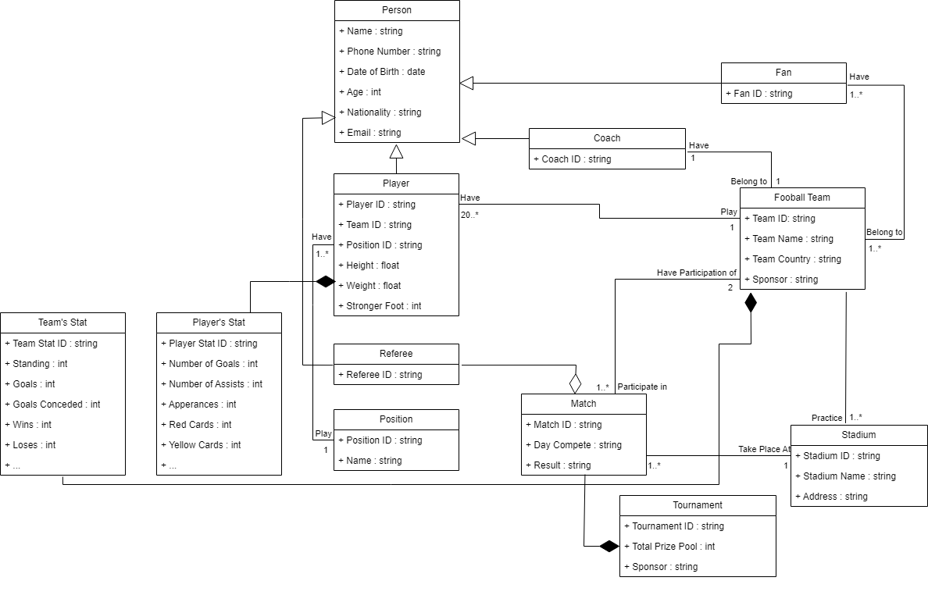

## **Sequence diagram**

* + 1. **Tạo tài khoản**

* + 1. **Đăng nhập**

* + 1. **Đăng ký hồ sơ**

* + 1. **Lập lịch thi đấu**

* + 1. **Ghi nhận kết quả trận đấu**

* + 1. **Tra cứu cầu thủ**

* + 1. **Lập báo cáo giải**

* + 1. **Thay đổi hoặc thêm mới qui định**

## **Screen**

### Create Account Screen

* + - 1. Main flow

|  |  |
| --- | --- |
| **Screen** | Create Account |
| **Description** | Create account |
| **Screen Access** | Users click on sign up button |

* + - 1. User Interface

* + - 1. Validation Rule/Data mapping

|  |  |  |
| --- | --- | --- |
| **Field** | **Type** | **Description** |
| Username | Label | * Username * Insert to field in DB: NFLM_USER. USERNAME |
| Password | Label | * Password * Insert to field in DB: NFLM_USER. PASSWORD |
| Email | Label | * Email * Insert to field in DB: NFLM_USER. EMAIL |
| Sign up with Google | Button | * Create account with Google email & username |
| Sign up with Facebook | Button | * Create account with Facebook email & username |
| Create Account | Button | * Request acknowledgment to system to record |
| Login | Link | * Link to login page |

### Sign-in Screen

* + - 1. Main flow

|  |  |
| --- | --- |
| **Screen** | Sign-in |
| **Description** | Sign-in |
| **Screen Access** | Users click on login button |

* + - 1. User Interface

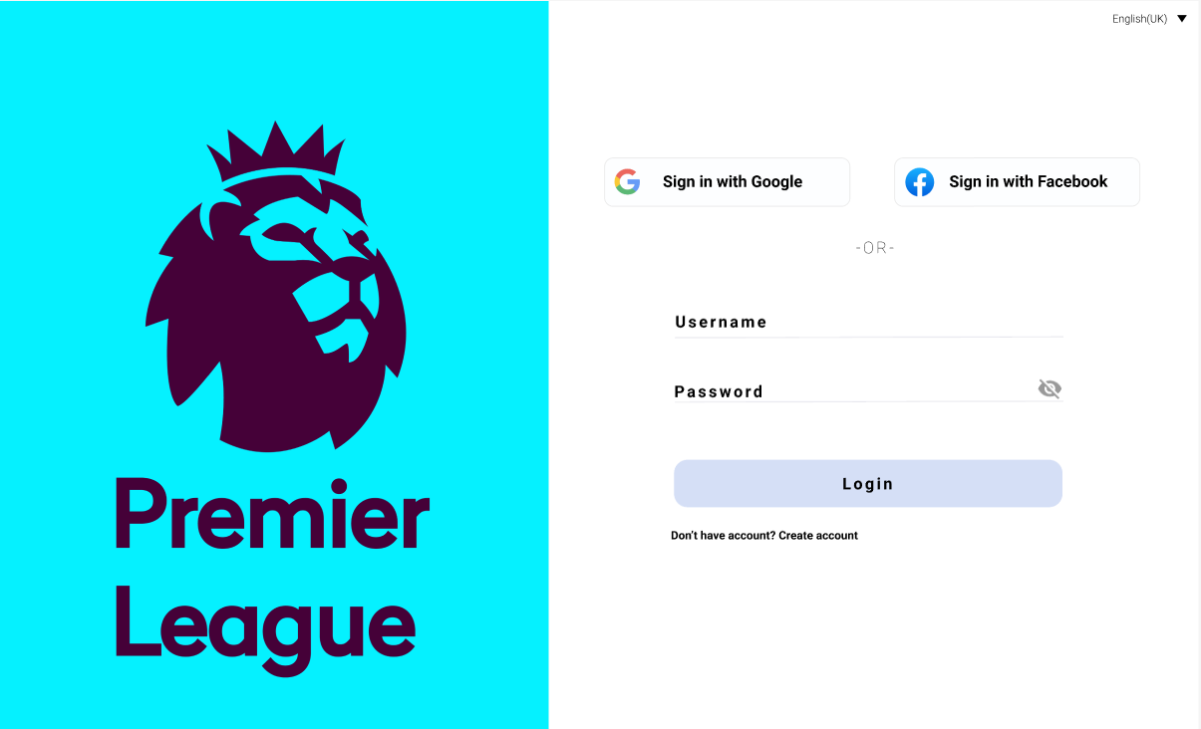

* + - 1. Validation Rule/Data mapping

|  |  |  |
| --- | --- | --- |
| **Field** | **Type** | **Description** |
| Username | Label | * Username * Mapping to field in DB: NFLM_USER. USERNAME |
| Password | Label | * Password * Mapping to field in DB: NFLM_USER. PASSWORD |
| Email | Label | * Email |
| Sign up with Google | Button | * Log in with Google email & username |
| Sign up with Facebook | Button | * Log in with Facebook email & username |
| Login | Button | * Request acknowledgment to system to sign in |
| Create Account | Link | * Link to create account page |

### Homepage Screen

* + - 1. Main flow

|  |  |
| --- | --- |
| **Screen** | Home page |
| **Description** | Home page |
| **Screen Access** | Users sign in or click to home button |

* + - 1. User Interface

Home page section

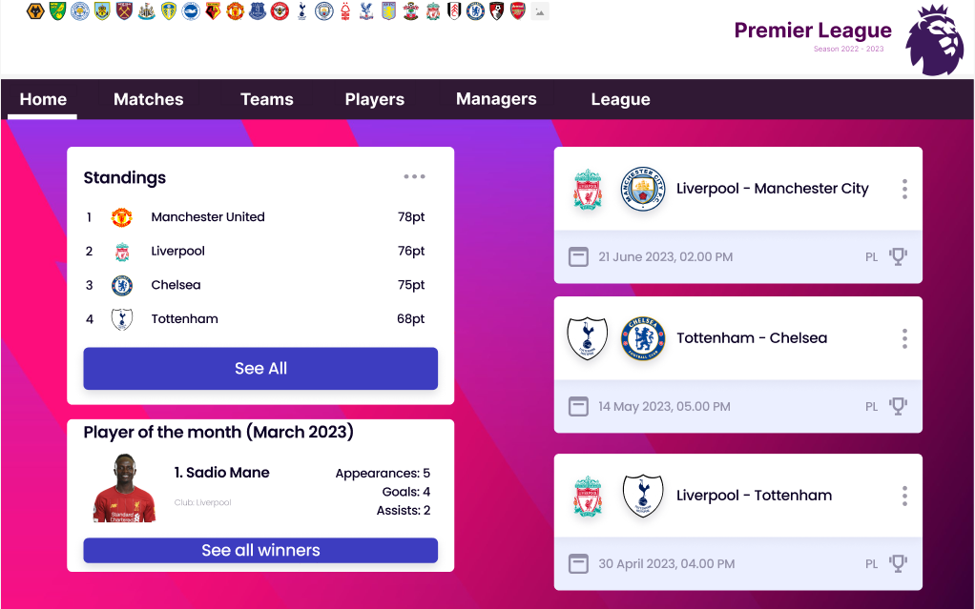

Standings table section

* + - 1. Validation Rule/Data mapping

|  |  |  |
| --- | --- | --- |
| **Field** | **Type** | **Description** |
| Standings | Dropdown list | * Standings * Display top 4 team’s standing * Mapping to field in DB: NFLM_TEAM’S STAT. STANDING |
| Player of the month | Dropdo wn list | * Player of the month * Display top 1 player * Mapping to field in DB: NFLM_PLAYER’S STAT. STANDING   NFLM_PLAYER’S STAT. NoG  NFLM_PLAYER’S STAT. NoA  NFLM_PLAYER. NAME |
| See all winners | Button | * List all data about player of the month |
| See all | Button | * List all data about team’s standing |
| Home | Button | * Link to home page |
| Matches | Button | * Link to matches page |
| Teams | Button | * Link to teams page |
| Players | Button | * Link to players page |
| Managers | Button | * Link to managers page |
| League | Button | * Link to league page |

### Matches Screen

* + - 1. Main flow

|  |  |
| --- | --- |
| **Screen** | Matches |
| **Description** | Matches |
| **Screen Access** | Users click on matches button |

* + - 1. User Interface

* + - 1. Validation Rule/Data mapping

|  |  |  |
| --- | --- | --- |
| **Field** | **Type** | **Description** |
| Results | Dropdown list | * Results * Display matches result * Mapping to field in DB: NFLM_MATCH. RESULT |
| Fixtures | Dropdown list | * Match schedules * Display matches schedules |
| Home | Button | * Link to home page |
| Matches | Button | * Link to matches page |
| Teams | Button | * Link to teams page |
| Players | Button | * Link to players page |
| Managers | Button | * Link to managers page |
| League | Button | * Link to league page |

### Teams Screen

* + - 1. Main flow

|  |  |
| --- | --- |
| **Screen** | Teams |
| **Description** | Teams |
| **Screen Access** | Users click on teams button |

* + - 1. User Interface

* + - 1. Validation Rule/Data mapping

|  |  |  |
| --- | --- | --- |
| **Field** | **Type** | **Description** |
| Clubs | Dropdown list | * Teams * Display all teams * Mapping to field in DB: NFLM_TEAM |
| Home | Button | * Link to home page |
| Matches | Button | * Link to matches page |
| Teams | Button | * Link to teams page |
| Players | Button | * Link to players page |
| Managers | Button | * Link to managers page |
| League | Button | * Link to league page |

### Players Screen

* + - 1. Main flow

|  |  |
| --- | --- |
| **Screen** | Players |
| **Description** | Players |
| **Screen Access** | Users click on players button |

* + - 1. User Interface

* + - 1. Validation Rule/Data mapping

|  |  |  |
| --- | --- | --- |
| **Field** | **Type** | **Description** |
| Players | Dropdo wn list | * Players * Display all players * Mapping to field in DB: NFLM_PLAYER |
| Home | Button | * Link to home page |
| Matches | Button | * Link to matches page |
| Teams | Button | * Link to teams page |
| Players | Button | * Link to players page |
| Managers | Button | * Link to managers page |
| League | Button | * Link to league page |

### Managers Screen

* + - 1. Main flow

|  |  |
| --- | --- |
| **Screen** | Managers |
| **Description** | Managers |
| **Screen Access** | Users click on managers button |

* + - 1. User Interface

* + - 1. Validation Rule/Data mapping

|  |  |  |
| --- | --- | --- |
| **Field** | **Type** | **Description** |
| Managers | Dropdo wn list | * Managers * Display all managers * Mapping to field in DB: NFLM_MANAGER |
| Home | Button | * Link to home page |
| Matches | Button | * Link to matches page |
| Teams | Button | * Link to teams page |
| Players | Button | * Link to players page |
| Managers | Button | * Link to managers page |
| League | Button | * Link to league page |

### League Info Screen

* + - 1. Main flow

|  |  |
| --- | --- |
| **Screen** | League |
| **Description** | League |
| **Screen Access** | Users click on league button |

* + - 1. User Interface

* + - 1. Validation Rule/Data mapping

|  |  |  |
| --- | --- | --- |
| **Field** | **Type** | **Description** |
| Standings | Button | * Link to standings page |
| Awards | Button | * Link to awards page |
| Stats and Records | Button | * Link to stats and records page |
| Regulations | Button | * Link to regulations page |
| Reports | Button | * Link to reports page |
| Home | Button | * Link to home page |
| Matches | Button | * Link to matches page |
| Teams | Button | * Link to teams page |
| Players | Button | * Link to players page |
| Managers | Button | * Link to managers page |
| League | Button | * Link to league page |

### Regulations Screen

* + - 1. Main flow

|  |  |
| --- | --- |
| **Screen** | Regulations |
| **Description** | Regulations |
| **Screen Access** | Users click on league button then click on regulations button |

* + - 1. User Interface
      2. Validation Rule/Data mapping

|  |  |  |
| --- | --- | --- |
| **Field** | **Type** | **Description** |
| Regulations | Dropdo wn list | * Regulations * Display all regulations * Mapping to field in DB: NFLM_REGULATION |
| Home | Button | * Link to home page |
| Matches | Button | * Link to matches page |
| Teams | Button | * Link to teams page |
| Players | Button | * Link to players page |
| Managers | Button | * Link to managers page |
| League | Button | * Link to league page |

### Reports Screen

* + - 1. Main flow

|  |  |
| --- | --- |
| **Screen** | Reports |
| **Description** | Reports |
| **Screen Access** | Users click on league button then click on reports button |

* + - 1. User Interface
      2. Validation Rule/Data mapping

|  |  |  |
| --- | --- | --- |
| **Field** | **Type** | **Description** |
| Reports | Dropdo wn list | * Regulations * Display all reports |
| Home | Button | * Link to home page |
| Matches | Button | * Link to matches page |
| Teams | Button | * Link to teams page |
| Players | Button | * Link to players page |
| Managers | Button | * Link to managers page |
| League | Button | * Link to league page |

### Awards Screen

* + - 1. Main flow

|  |  |
| --- | --- |
| **Screen** | Awards |
| **Description** | Awards |
| **Screen Access** | Users click on league button then click on awards button |

* + - 1. User Interface
      2. Validation Rule/Data mapping

|  |  |  |
| --- | --- | --- |
| **Field** | **Type** | **Description** |
| Awards | Dropdo wn list | * Regulations * Display all awards |
| Home | Button | * Link to home page |
| Matches | Button | * Link to matches page |
| Teams | Button | * Link to teams page |
| Players | Button | * Link to players page |
| Managers | Button | * Link to managers page |
| League | Button | * Link to league page |

### League Standings Screen

* + - 1. Main flow

|  |  |
| --- | --- |
| **Screen** | League Standings |
| **Description** | League standings |
| **Screen Access** | Users click on league button then click on standings button |

* + - 1. User Interface

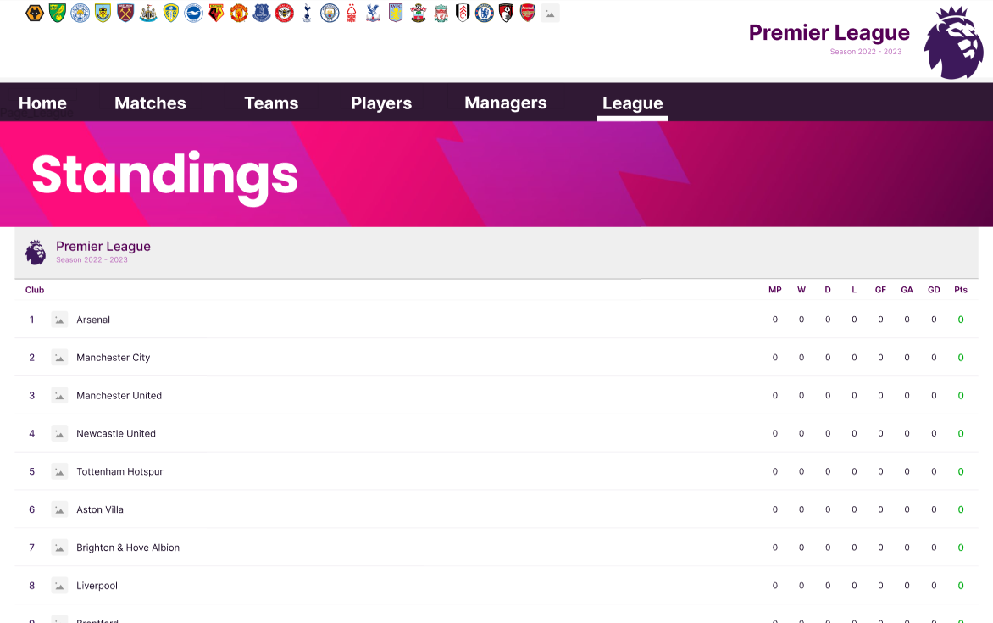

* + - 1. Validation Rule/Data mapping

|  |  |  |
| --- | --- | --- |
| **Field** | **Type** | **Description** |
| Standings | Dropdo wn list | * Standings * Display all teams with rank filtered * Mapping to field in DB: NFLM_TEAM   NFLM_TEAM’S STAT |
| Home | Button | * Link to home page |
| Matches | Button | * Link to matches page |
| Teams | Button | * Link to teams page |
| Players | Button | * Link to players page |
| Managers | Button | * Link to managers page |
| League | Button | * Link to league page |

### Stats & Records Screen

* + - 1. Main flow

|  |  |
| --- | --- |
| **Screen** | Stats & Records |
| **Description** | Stats & Records |
| **Screen Access** | Users click on league button then click on stats & records button |

* + - 1. User Interface
      2. Validation Rule/Data mapping

|  |  |  |
| --- | --- | --- |
| **Field** | **Type** | **Description** |
| Stats | Dropdo wn list | * Stats * Display all players with their stats * Mapping to field in DB: NFLM_PLAYER’S STAT |
| Records | Dropdo wn list | * Records * Display all match records * Mapping to field in DB: NFLM_MATCH. RESULT |
| Home | Button | * Link to home page |
| Matches | Button | * Link to matches page |
| Teams | Button | * Link to teams page |
| Players | Button | * Link to players page |
| Managers | Button | * Link to managers page |
| League | Button | * Link to league page |